**Query Metadata Parser Documentation**

**Problem Statement**

**Solution**

**Architecture Diagram**

**Prerequisites**

Tools/Technologies used

1. Python
2. SQLite Database
3. Jinja Framework
4. Bootstrap Framework
5. HTML, CSS

Required Python packages

1. Flask
2. Sqlite3
3. Sqlparse

Project Structure

---------QueryMetadataParser  
 ├── __init__.py # setup your app  
 ├── query_parser.py # Code for SQL Query Parsing  
 ├── create_sqlite_db.py # Database Creation   
 ├── app.py # Flask Code  
 ├── db.sqlite # your database  
 └── templates  
 ├── display_all_metadata.html # display all type of metadata  
 ├── display_metadata.html # display selected metadata  
 ├── index.html # show the login form  
 ├── successful_file_upload.html # SQL script upload to directory   
 └── successful_login.html # page after login

└── type_of_metadata.html # select type of metatdata

└── upload_sql_script.html # form to upload sql script

└── style.css # css

└── UploadedSQLScripts

└── SQL_Script_1.html # sql scripts uploaded in this directory

└── SQL_Script_2.html # sql scripts uploaded in this directory

**Technical Implementation**

1. Prepare your Environment
2. Create a virtual environment in python

virtualenv venv sql_parser

1. Install the python packages in the virtual environment described in the pre-requisite section.

flask  
flask-sqlalchemy  
flask-login  
werkzeug  
pandas

To install packages pip install package_name or you can create a new file requirements.txt (this file will contains one package name each row) and install all packages once using : pip install -r requirements.txt

1. Create project structure as mentioned in the pre-requisite section.
2. Create Database
3. Create Sqlite Database – QMP_DB.db

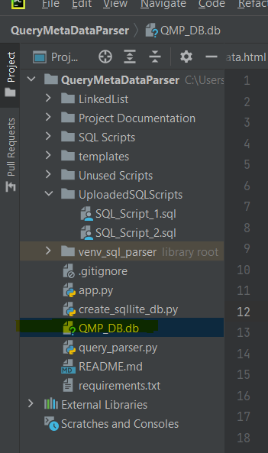

1. Create Tables dropdownlist and users in the database QMP_DB.db

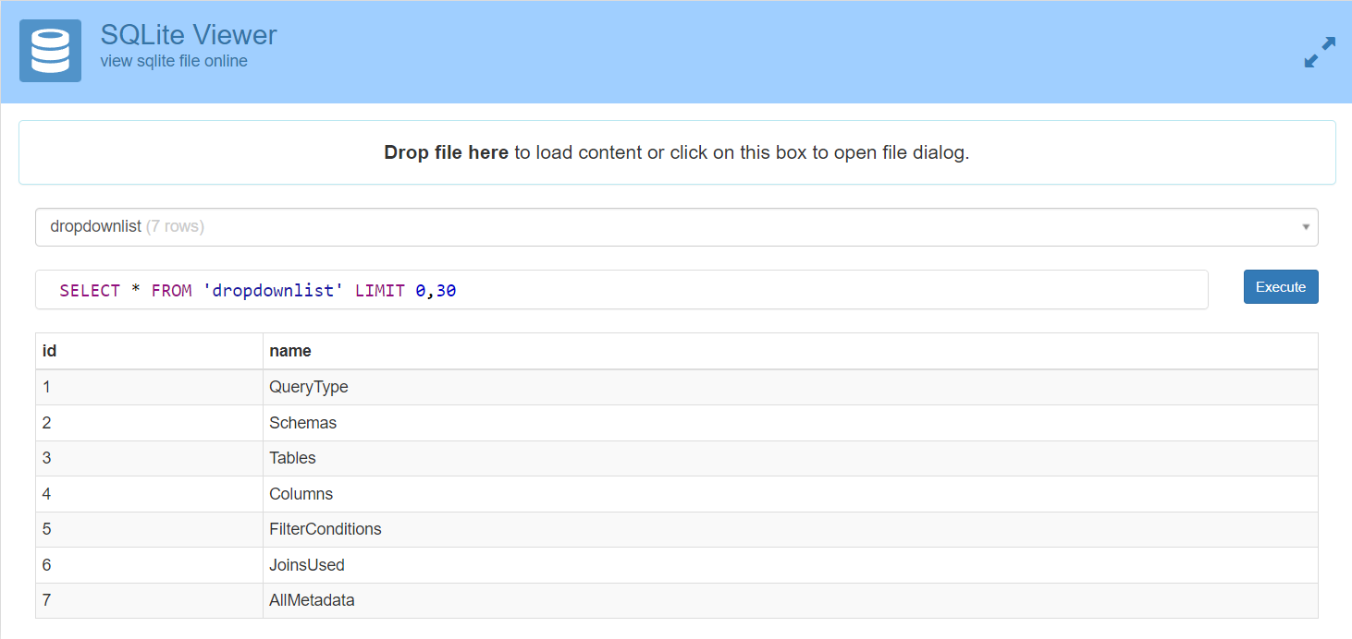

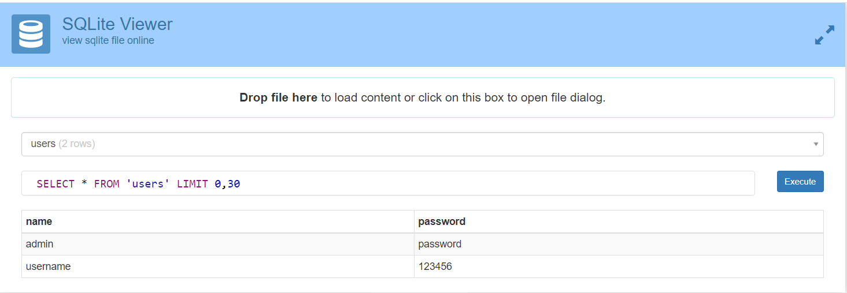

1. Create Web Pages

* Enter user details and login to the Query Metadata Parser portal.
* The application will validate the user details with the credentials stored in the Sqlite database and if it matches it will redirect to the next page.

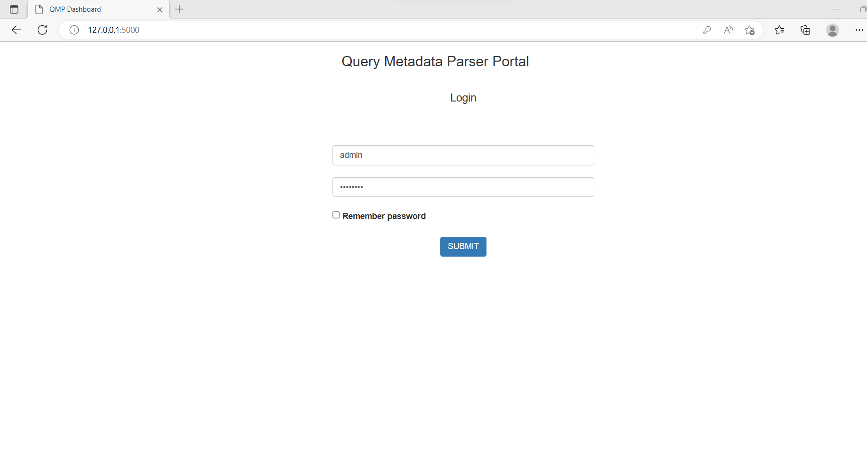

* Click on Analyze Metadata button post successful login.

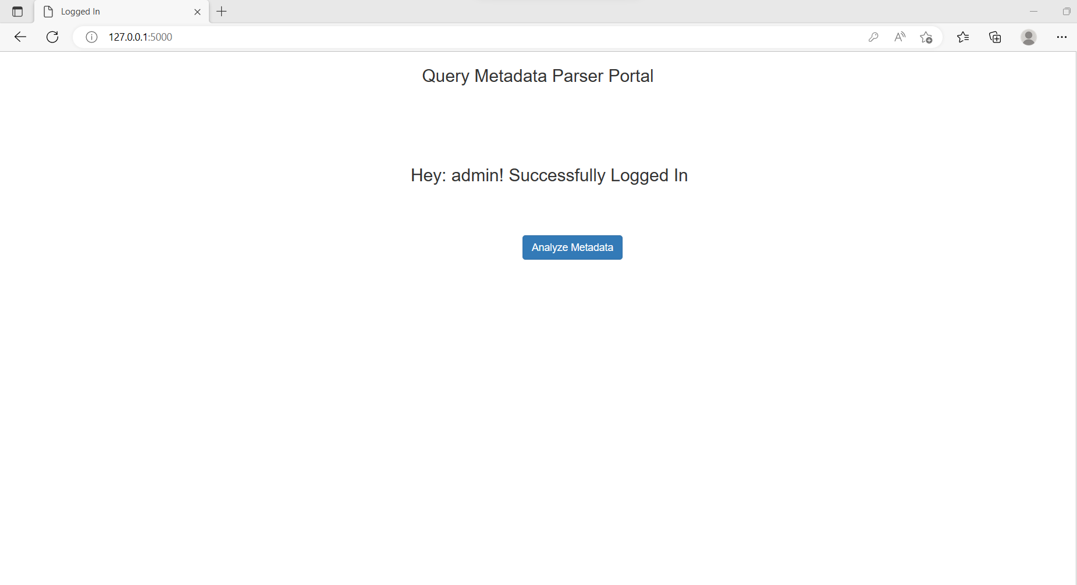

* Choose a SQL Script from your local device and upload it to the portal.

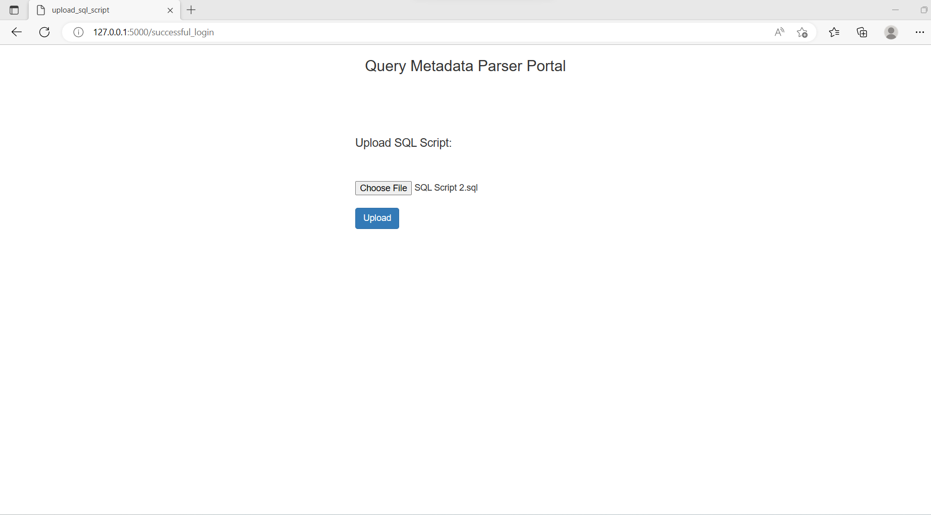

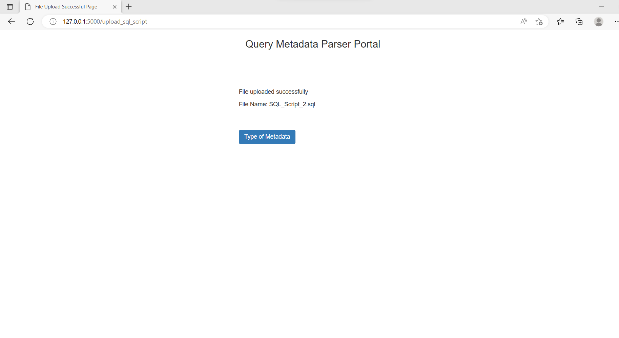

* Choose the type of Metadata that you want to display.

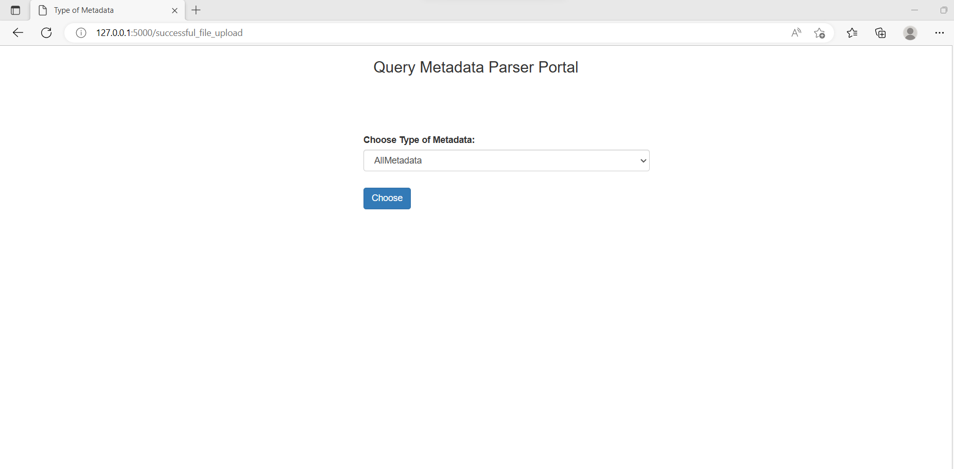

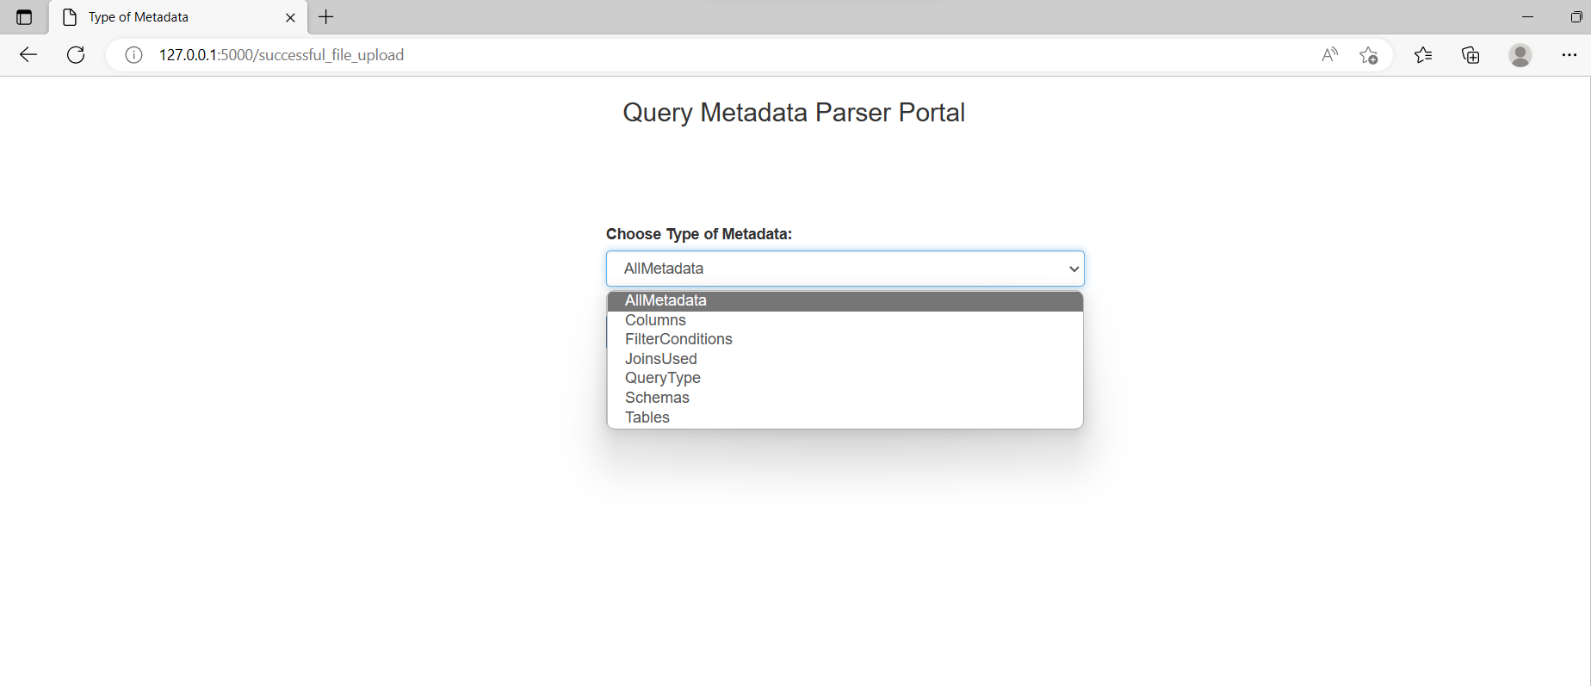

* Based on the Metadata type selection, Metadata information would be displayed.

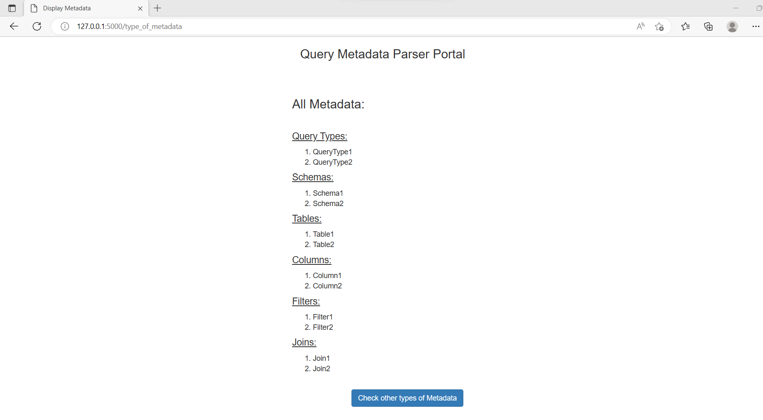

* Check other types of metadata by clicking on the button “Check other types of Metadata”.

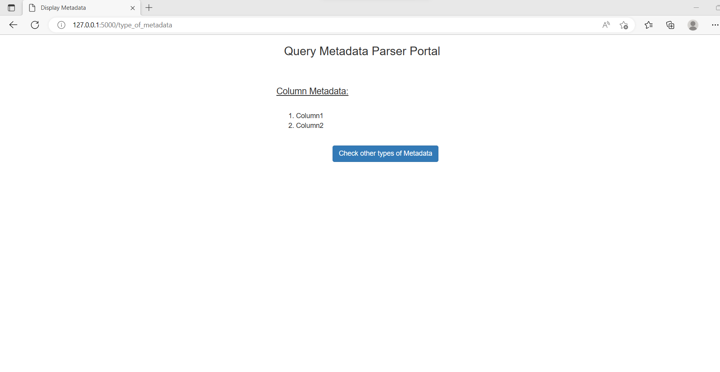

1. Connect Web Pages using the Flask Framework

* Connect to sqlite database.
* Create routing methods to route/redirect web pages based on the GET/POST.

**Conclusion**

**GitHub link**

* <https://github.com/tariniteam/QueryMetaDataParser>

**Contributors**

1. Harsha Navalkar ( <https://www.linkedin.com/in/harsha-navalkar-00085515b/> )
2. Vikram Mahapatra ()